

TITLE – BAHIRDAR UNIVERSITY DISTANCE

LEARNING

**MEMBERS OF THE GROUP**

**NAME IDNO**

1. Tamiru Zenebe………..…1795/03

2. Yosefe Kefale……………0401780

3. Teshager Wossen………...04017575

THIRD YEAR CSED

SUBMMITED TO: Mr.Tsegaw

SUBMMITED DATE: 24/10/2006

Table of Content

ContentPage

**Chapter one**

**Fundamental Database Concepts**

**Introduction**

Background of Bahir Dar University

BahirDar University was established by merging two former higher education institutions; namely the Bahir Dar Polytechnic and Bahir Dar Teachers’ College. The Bahir Dar Polytechnic Institute, which has transformed itself into Technology and Textile institutes, was established in 1963 under the technical cooperation between the Government of USSR and the Imperial Government of Ethiopia.  The institute was a premier institute in producing technicians for the nation.

The two institutions of higher learning were integrated to form the Bahir Dar University following the Council of Ministers regulation no. 60/1999 GC. The University was inaugurated on May 6, 2000.  Bahir Dar University is now among the largest universities in the Federal Democratic Republic of Ethiopia, with more than 35,000 students in its 57 undergraduate and 39 graduate programs.  Bahir Dar University has four colleges, three institutes, three faculties and one school.  The academic units of the University include College of Science, College of Agriculture and Environmental Sciences, College of Medical and Health Sciences, College of Business and Economics, Institute of Technology, Institute of Textile, Garment and Fashion Design, Institute of Land Administration, Blue Nile Water Institute, Faculty of Humanities, Faculty of Social Sciences, Faculty of Education and Behavioral Sciences and School of Law.

Bahirdar university also gives a distance education for most of the departments given on the regular course.

**Objectives of the Project**

Specific objective of the project

The following are specific objectives of our project:

* Implement validation techniques and checks that will help reduce the margin of error in operations.
* Provides adequate data backup facilities in order to ensure system restart even after a calamity.
* The system ensures consistency.
* Should arrive at and obtain a complete automation of all the registers as well as the registers, which are used for smooth working of the firm.
* The system is a reusable and extensible model/code.

General objectives of the project

The general objective of our project is to replaces the present manual system to web based system and stimulates the need of the student. The system also solves many problems besides to distance learning Such as:

* Providing appropriate learning materials and assignments for the student where ever they are.
* Let professor give materials and assignments where ever they are.
* Let administrator place in well manner.

Scope of the Project

* The system will not let any user use basic operation unless a user has an account..
* The system lets any user to see information about bahir dar distance education (learning).
* The system lets to download any learning materials.

Project deliverables

ENTITIY RELATION DIAGRAM

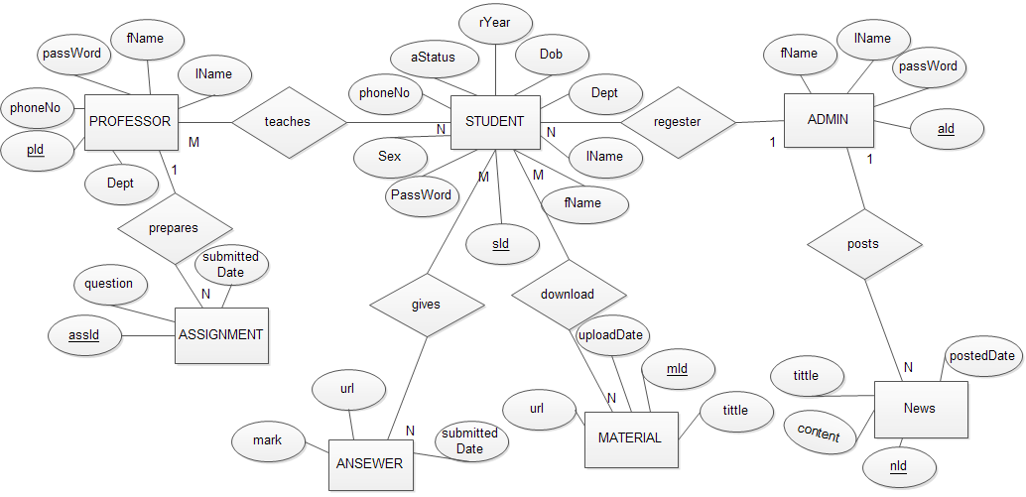

DATABASE DIAGRAM

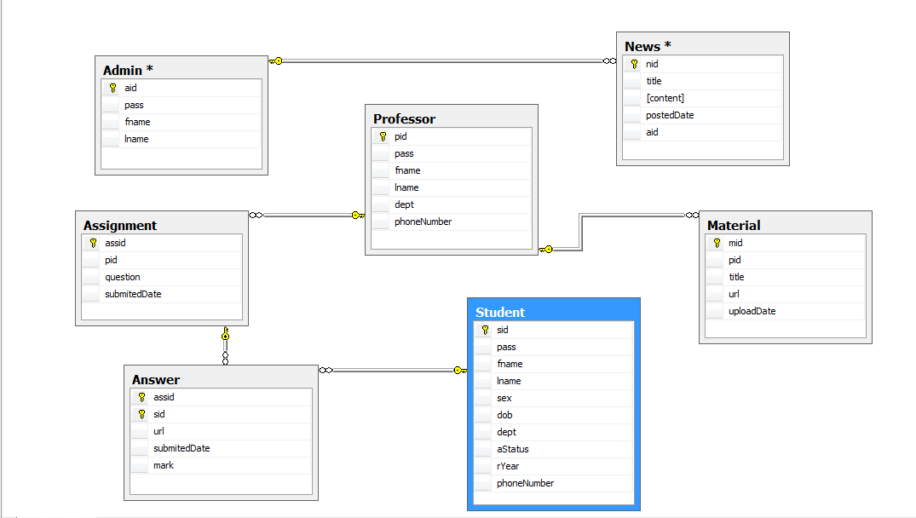

RATIONAL MAPPING

Student

|  |  |  |  |  |  |  |  |  |  |
| --- | --- | --- | --- | --- | --- | --- | --- | --- | --- |
| SId | password | FName | LName | Sex | dob | dept | rYear | aStatus | PhoneNo |

**Professor**

|  |  |  |  |  |  |
| --- | --- | --- | --- | --- | --- |
| pid | password | fName | lName | dept | PhoneNo |

**Admin**

|  |  |  |  |
| --- | --- | --- | --- |
| aId | password | fName | Lname |

**Assignment**

|  |  |  |  |
| --- | --- | --- | --- |
| AssId | pid | question | submittedDate |

**Anawer**

|  |  |  |  |  |
| --- | --- | --- | --- | --- |
| AssId | SId | url | submittedDate | mark |

**Material**

|  |  |  |  |  |
| --- | --- | --- | --- | --- |
| mId | pid | title | url | uploadDate |

**News**

|  |  |  |  |  |
| --- | --- | --- | --- | --- |
| nId | aid | content | title | postedDate |

NORMALIZATION

A logical design method which minimizes data redundancy and reduces design flows

* Consists of applying various “normal” forms to the database design.
* The normal forms break down large tables into smaller subsets.

FIRST NORMAL FORM (1NF)

* Each attribute must be atomic
* No repeating columns within a row.
* No multi-valued columns.

SECOND NORMAL FORM (2NF)

* Each attribute must be functionally dependent on the primary key.
* Functional dependence - the property of one or more attributes that uniquely determines the value of other attributes.
* Any non-dependent attributes are moved into a smaller (subset) table.

THIRD NORMAL FORM (3NF)

* Remove transitive dependencies.
* Transitive dependence - two separate entities exist within one table.
* Any transitive dependencies are moved into a smaller (subset) table.

In this case all the table i.e. Student, Professor, Admin, Assignment, Answer, Material and News satisfies the normalization form up to third normal form.

Implementation database

* First we create database Name BDU_DL And create Tables as Folows

CREATE DATABASE BDU_DL;

USE BDU_DL;

* We have Sven Possible Tables

CREATE TABLE Student

(

[sid] INT PRIMARY KEY IDENTITY,

pass VARCHAR(50) NOT NULL DEFAULT('bdu'),

fname VARCHAR(50) NOT NULL,

lname VARCHAR(50) NOT NULL,

sex VARCHAR(6) NOT NULL CHECK(sex IN ('Male','Female')),

dob DATE NOT NULL,

dept VARCHAR(50) NOT NULL,

aStatus INT NOT NULL CHECK(aStatus > 290),

rYear INT NOT NULL DEFAULT(YEAR(GETDATE())),

phoneNumber VARCHAR(50) NOT NULL

)

CREATE TABLE Professor

(

pid INT PRIMARY KEY IDENTITY,

pass VARCHAR(50) NOT NULL DEFAULT('bdu'),

fname VARCHAR(50) NOT NULL,

lname VARCHAR(50) NOT NULL,

dept VARCHAR(50) NOT NULL,

phoneNumber VARCHAR(50) NOT NULL

)

CREATE TABLE [Admin]

(

aid INT PRIMARY KEY IDENTITY,

pass VARCHAR(50) NOT NULL,

fname VARCHAR(50) NOT NULL,

lname VARCHAR(50) NOT NULL

)

CREATE TABLE Assignment

(

assid INT PRIMARY KEY IDENTITY,

pid INT FOREIGN KEY REFERENCES Professor,

question TEXT NOT NULL,

submitedDate DATETIME NOT NULL DEFAULT(GETDATE())

)

CREATE TABLE Material

(

mid INT PRIMARY KEY IDENTITY,

pid INT FOREIGN KEY REFERENCES Professor,

title VARCHAR(100) NOT NULL,

url VARCHAR(100) NOT NULL,

uploadDate DATETIME NOT NULL DEFAULT(GETDATE())

)

CREATE TABLE Answer

(

assid INT FOREIGN KEY REFERENCES Assignment,

[sid] INT FOREIGN KEY REFERENCES Student,

url VARCHAR(100) NOT NULL,

submitedDate DATETIME NOT NULL DEFAULT(GETDATE()),

mark float CHECK(mark >= 0 AND mark < 100),

CONSTRAINT pk_answer PRIMARY KEY(assid,[sid])

)

CREATE TABLE News

(

nid INT PRIMARY KEY IDENTITY,

title VARCHAR(100) NOT NULL,

content VARCHAR(1000) NOT NULL,

postedDate DATETIME NOT NULL DEFAULT(GETDATE())

)